Background

On April 19, 2022, the Maryland Department of the Environment (MDE) began monitoring Back River (Baltimore County) in the vicinity of where the Back River Wastewater Treatment Plant (WWTP) outfall discharges into the river. The purpose of the sampling is to understand how WWTP performance problems may be impacting water quality. Bacterial (Enterococcus and E. Coli) sampling is conducted weekly at four sites (Figure 1).
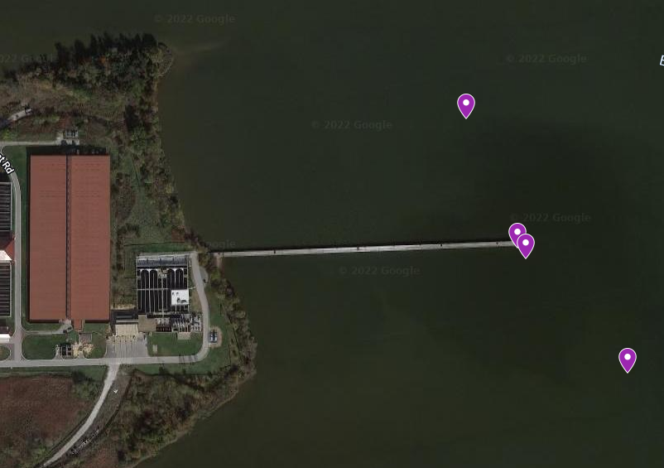
MDE_BRB_3
MDE_BRB_2
MDE_BRB_1
MDE_BRB_4
Figure 1: MDE_BRB_1 is 500 feet upriver from the outfall; MDE_BRB_2 is at the outfall; MDE_BRB_3 is 50 feet downriver from the outfall; and, MDE_BRB_4 is 600 downriver from the outfall.
The analytical method used can detect the following species of Enterococci.
- faecalis
- faecium
- avium
- gallinarum
- casseliflavus
- durans
MDE provides guidance for the County Recreational Water Quality Monitoring and Notification Program, which is adapted from the U.S. Environmental Protection Agency (EPA) National Beach Guidance. While this sampling area is not a designated beach, state guidance for beaches can assist in the interpretation of the monitoring results.

As described in the MDE guidance, the purpose of recreational water quality monitoring for bacteria contamination is to inform management actions that reduce the incidence of human illness that arises from contamination of recreational water areas, in particular waters where water contact includes full submersion (swimming). The purpose of water quality indicator testing is to measure the concentration of a bacterial indicator species that are not necessarily a pathogen but whose levels are associated with fecal indicator bacteria and human illness derived from EPA epidemiological studies at beaches. High levels of fecal indicator bacteria suggest water contamination with human or animal fecal matter and resulting potential risk to human health due to the potential for human pathogens to be present.

The guidance includes a Beach Action Level (BAL) that is used to inform beach notifications (also see COMAR 26.08.09.01). For example, with designated beaches, if sample results report an indicator organism density above the BAL, then the county should issue a public notification for a beach advisory. If subsequent sampling results in indicator densities below the BAL, then advisories can be lifted. The BAL for Enterococci is 104 Most Probable Number (MPN)/100 milliliters (mL), and the BAL for E. Coli is 235 MPN/100 mL.

The Back River WWTP National Pollutant Discharge Elimination System (NPDES) Permit has a monthly geometric mean permit limit of 126 MPN/100 ml for E. coli., which is consistent with Maryland Surface Water Quality Criteria (26.08.02.03-3). The monthly geometric mean permit limit is assessed using multiple samples collected over a 30-day monitoring period.

Monitoring Results

Bacterial indicator monitoring results for both Enterococci (Figure 2) and E. Coli (Figure 3) show wide fluctuation in values, with the highest values observed when monitoring occurs within 48 hours of a significant (approximately 1-inch) rain event. Rain events are determined from the National Atmospheric Administration Data at Baltimore Washington International Airport.

Sampling events on April 19, May 9, May 24, and July 6 all occurred after significant rain events of 1.22-inches, 2.32-inches, 0.91-inches, and 1.06-inches, respectively. Data at stations sampled after these rain events routinely exceeded the BAL for both Enterococci and E. Coli. The June 15 sampling occurred after 0.26-inches of rain within the prior 48 hours; however, there were a total of 2.19-inches of rain over the course of the week preceding the June 15 sampling. Despite the precipitation, the BAL for both Enterococci and for E. Coli were generally not exceeded. The exception was the outfall station MDE_BRB_2, which exceeded the BAL for E. Coli.

Sampling dates (April 27, May 4, May 9, June 1, June 8, June 22, June 29, July 6, July 13, July 20, July 27, August 3 and 17) that were not preceded by significant rain showed lower Enterococci and E. Coli values, and generally do not exceed the BAL.

Outside of wet and dry weather influence on bacteria indicator concentrations, there are no other clear trends either at or between sampling stations. This may be due to multiple bacterial sources in the larger Back River watershed, tidal influences on water quality, and natural variability in bacteria concentrations.

Figure 2: Enterococci sampling results from Back River in the vicinity of the WWTP outfall.
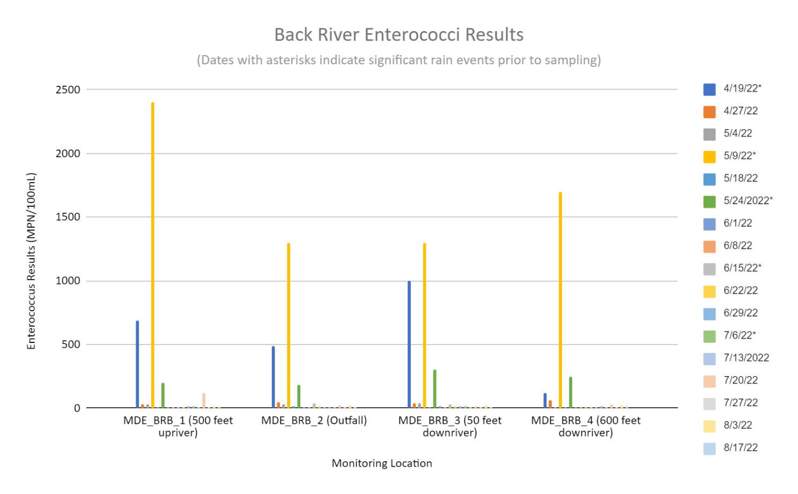

Beach Action Value 104
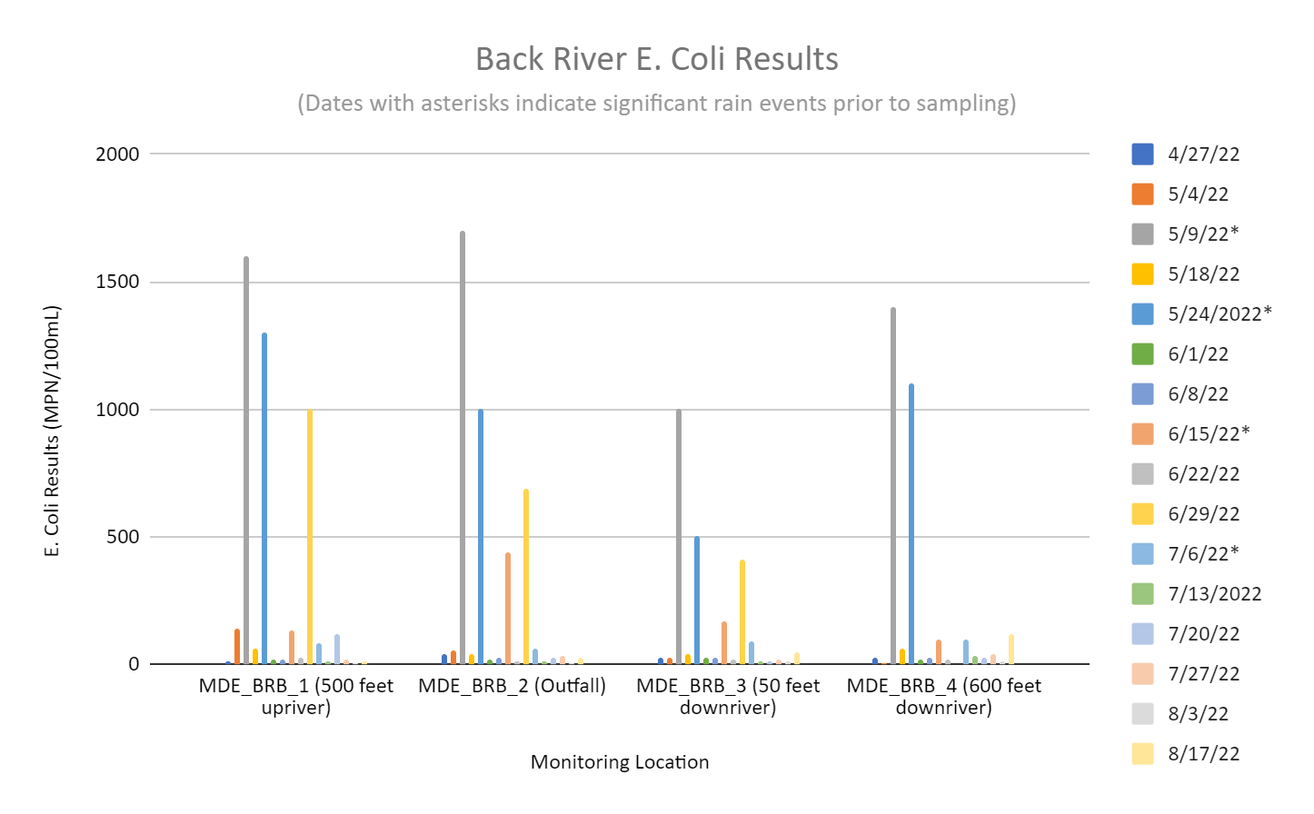

Beach Action Value 235
Figure 3: E. Coli sampling results from Back River in the vicinity of the WWTP outfall.

